**Hive - GNS3 project**

CentOS machines ➡️ username: root

password: osboxes.org

cloud has been set as *virbr0*, router as *cisco 7200* with this configuration:

!

!

upgrade fpd auto

version 12.4

service timestamps debug datetime msec

service timestamps log datetime msec

no service password-encryption

!

hostname R1

!

boot-start-marker

boot-end-marker

!

logging message-counter syslog

!

no aaa new-model

ip source-route

no ip icmp rate-limit unreachable

ip cef

!

!

ip dhcp excluded-address 10.0.0.1

!

ip dhcp pool LAN

network 10.0.0.0 255.255.255.0

default-router 10.0.0.1

dns-server 8.8.8.8

!

!

no ip domain lookup

no ipv6 cef

!

multilink bundle-name authenticated

!

!

!

!

!

!

!

!

!

!

!

!

!

!

!

!

archive

log config

hidekeys

!

!

!

!

!

ip tcp synwait-time 5

!

!

!

!

interface FastEthernet0/0

ip address 192.168.122.2 255.255.255.0

ip nat outside

ip virtual-reassembly

duplex auto

speed auto

!

interface FastEthernet0/1

ip address 10.0.0.1 255.255.255.0

ip nat inside

ip virtual-reassembly

duplex auto

speed auto

!

ip forward-protocol nd

ip route 0.0.0.0 0.0.0.0 192.168.122.1

ip route 192.168.122.0 255.255.255.0 10.0.0.0

no ip http server

no ip http secure-server

!

!

ip nat inside source list 1 interface FastEthernet0/0 overload

!

access-list 1 permit 10.0.0.0 0.0.0.255

access-list 1 permit 192.168.122.0 0.0.0.255

no cdp log mismatch duplex

!

!

!

!

!

!

control-plane

!

!

!

!

!

!

!

gatekeeper

shutdown

!

!

line con 0

exec-timeout 0 0

privilege level 15

logging synchronous

stopbits 1

line aux 0

exec-timeout 0 0

privilege level 15

logging synchronous

stopbits 1

line vty 0 4

login

!

end

for server *Blot*’s configuration ➡️ nano /etc/nginx/conf.d/ssl.conf

➡️ 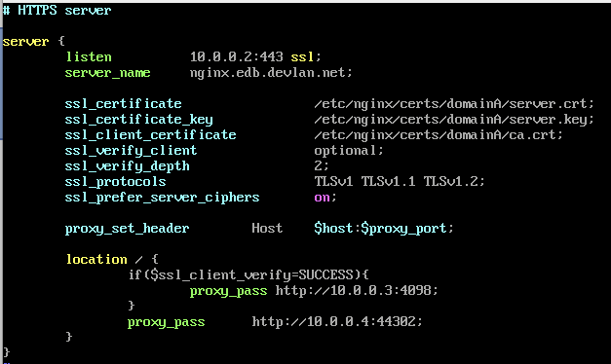

(still in Blot) you have to install nginx, in this way:

wget http://nginx.org/packages/centos/6/noarch/RPMS/nginx-release-centos-6-0.el6.ngx.noarch.rpm ⤵️

rpm -ivh nginx-release-centos-6-0.el6.ngx.noarch.rpm ⤵️

yum install nginx ⤵️

(see “hive-Infrastructure-Switchblade.pdf” for more)

(still in Blot) we have installed openvpn, in this way:

wget http://dl.fedoraproject.org/pub/archive/epel/6/i386/epel-release-6-8.noarch.rpm ⤵️

rpm -Uvh epel-release-6-8.noarch.rpm ⤵️

yum install openvpn ⤵️

(this installation also in the *VPS* machine)

in the *Raspberry* machine, you have to import from github the *honeycomb.py* file, we didn’t manage how to run it, the command found in the docs “python2 honeycomb.py -p 8080 -f /home/pi/Desktop/filepath -l /home/pi/Desktop/log” give us an error.

for the installations in the *Cover Server* and for the usage of the *redirection script* we followed ”hive-Infrastructure-Configuration_Guide.pdf”.